**LAB NO. 10**

**INTRODUCTION TO CISCO PACKET TRACER: PART 2**



**DATA COMMUNICATION AND COMPUTER NETWORKS LAB**

Submitted by:

Name : **Muhammad Musa**

Reg no**. : 22PWCSE2157**

ClassSection **: C**



Student Signature: ____________

Date: June 01 2025

**Submitted to:** **Dr. Yasir Saleem Afridi**

**Department of Computer Systems Engineering**

**University of Engineering and Technology, Peshawar**

**CSE 303L: Data Communication and Computer Networks**

|  |  |  |  |  |
| --- | --- | --- | --- | --- |
| **Demonstration of Concepts** | **Poor (Does not meet expectation (1))**  The student failed to demonstrate a clear understanding of the assignment concepts | **Fair (Meet Expectation (2-3))**  The student demonstrated a clear understanding of some of the assignment concepts | **Good (Exceeds Expectation (4-5)**  The student demonstrated a clear understanding of the assignment concepts | **Score**  **30%** |
| **Accuracy** | The student mis-configured enough network settings that the lab computer couldn't function properly on the network | The student configured enough network settings that the lab computer partially functioned on the network | The student configured the network settings that the lab computer fully functioned on the network | **30%** |
| **Following Directions** | The student clearly failed to follow the verbal and written instructions to successfully complete the lab | The student failed to follow the some of the verbal and written instructions to successfully complete all requirements of the lab | The student followed the verbal and written instructions to successfully complete requirements of the lab | **20%** |
| **Time Utilization** | The student failed to complete even part of the lab in the allotted amount of time | The student failed to complete the entire lab in the allotted amount of time | The student completed the lab in its entirety in the allotted amount of time | **20%** |

**Credit Hours: 1**

# LAB 10 INTRODUCTION TO CISCO PACKET TRACER: PART 2

## OBJECTIVES OF THE LAB

**--------------------------------------------------------------------------------------------------------------**

This lab aims to introduce Cisco Packet Tracer. Some specific topics covered in this lab are

* Creating Networks
* Making Connections
* Making LAN using Hub
* Making LAN using Switch
* Difference between hub and switch

**-------------------------------------------------------------------------------------------------------------**

## Introduction

Cisco Packet Tracer is an innovative network simulation and visualization tool. This free software helps you to practice your network configuration and troubleshooting skills via your desktop computer or an Android or iOS based mobile device. Packet Tracer is available for both the Linux and Windows desktop environments.

With Packet Tracer you can choose to build a network from scratch, use a pre-built sample network, or complete classroom lab assignments. Packet Tracer allows you to easily explore how data traverses your network. Packet Tracer provides an easy way to design and build networks of varying sizes without expensive lab equipment.

**Creating Devices**

* 1. Choose a device type from the Device-Type Selectionbox
  2. Click on the desired device model from the Device-Specific Selectionbox
  3. Click on a location in the workspace to put your device in that location
  4. If you want to cancel your selection, press the Cancel icon for that device
  5. Alternatively, you can click and drag a device from the Device-Specific Selectionbox onto the workspace
  6. You can also click and drag a device directly from the Device-Type Selectionbox and a default device model will be chosen for you

**Making Connections**

* 1. To make a connection between two devices, first click the Connections icon from the Device-Type Selectionbox to bring up the list of available connections.
  2. Then click the appropriate cable type.
  3. The mouse pointer will change into a "connection" cursor.
  4. Click on the first device and choose an appropriate interface to which to connect.
  5. Then click on the second device and do the same.
  6. A connection cable will appear between the two devices, along with link lights showing the link status on each end (for interfaces that have link lights).

**Creating Networks**

Packet Tracer is a cross-platform visual simulation tool designed by Cisco Systems that allows users to create network topologies and imitate modern computer networks. The software allows users to simulate the configuration of Cisco routers and switches using a simulated command line interface.

**Questions:**

1. Make a LAN using HUB in Cisco Packet Tracer.

1. Make LAN using SWITCH in Cisco Packet Tracer.

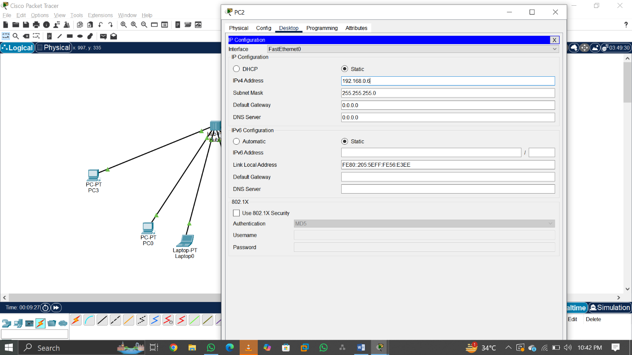

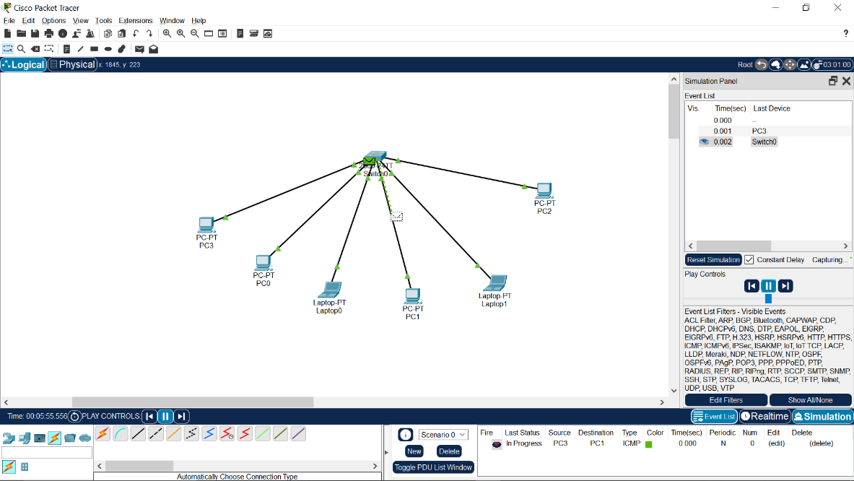

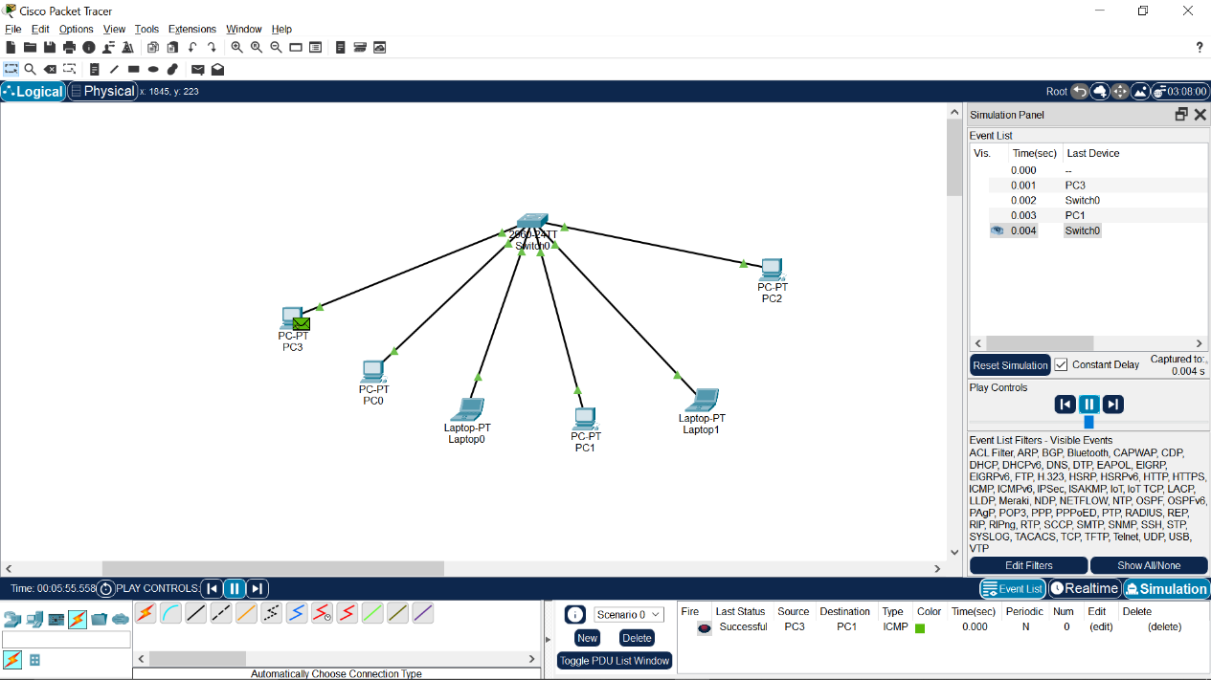

1. What are the pros and cons of HUB?

|  |  |
| --- | --- |
| **Pros** | **Cons** |
| Simple to use | Not intelligent – sends data to all ports (no filtering) |
| Cheap and easily available | Causes more network collisions |
| Works well in small/basic networks | Lower speed and performance compared to switches |
| No configuration needed | Cannot reduce unnecessary traffic (broadcasts everything) |

1. What are the pros and cons of SWITCH?

|  |  |
| --- | --- |
| **Pros** | **Cons** |
| Intelligent – sends data only to the destination | More expensive than hubs |
| Reduces collisions and improves performance | Configuration may be needed in advanced setups |
| Supports full-duplex communication | Cannot work properly if there’s a loop (without STP) |
| More secure than hubs | Requires power and might fail if overloaded |

1. Which ethernet cable did you use for the connection between HUB and PC? Straight-through Ethernet Cable (used to connect different types of devices, like a PC to a HUB.
2. What does a switch store in its memory?

A switch store its memory primarily in MAC Address Table (also called a CAM Table) that maps device MAC addresses to its switch ports.